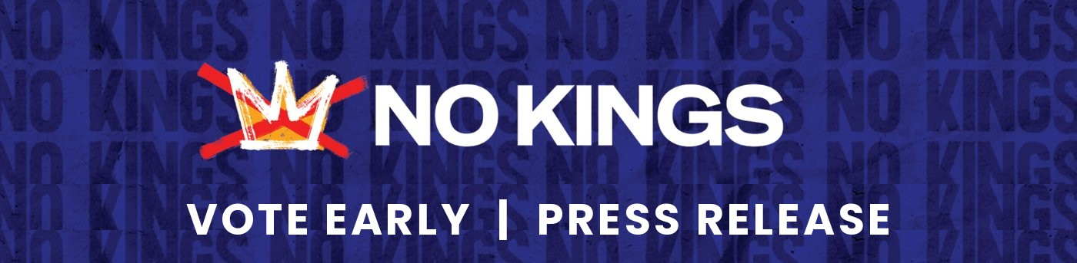
FOR IMMEDIATE RELEASE
October 18, 2026
Walking “Drop Boxes” Steal the Show as North Bethesda Neighbors Kick Off Early Voting
300 to 400 residents rally on Rockville Pike five days before Maryland’s one week of in-person early voting begins Oct. 22
NORTH BETHESDA, Md. – Between 300 and 400 Montgomery County residents dodged the rain on Saturday to line Rockville Pike for No Kings: Vote Early “On the Pike,” a peaceful, nonpartisan event urging neighbors to make a plan to vote during Maryland’s one week of in-person early voting, which begins Thursday, October 22.
The crowd favorites were life-size “Drop Box” costumes, white boxes trimmed with the Maryland flag, created by volunteer Monica Tinker and a small group of fellow volunteers. The walking drop boxes carried a practical message: voters can return completed mail-in ballots to any of Montgomery County’s 58 official drop boxes, open now through 8 PM on Election Day.
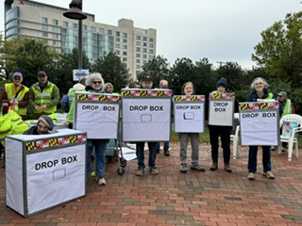
Volunteers in homemade “Drop Box” costumes on Rockville Pike, Oct. 17, 2026. Photo: No Kings North Bethesda.
About 50 volunteer marshals, first-aiders, and “advocates” staffed the event. Advocates handed out a two-sided flyer on early voting and protecting the vote, reaching beyond rally attendees to shoppers at the nearby Pike & Rose farmers market.
“For months, our neighbors stood out here because the ballot box wasn’t open yet. On Thursday, it opens. This is how we use the power we’ve built,” said Robin Daly, a lead organizer of No Kings North Bethesda.
The rally was part of No Kings: Vote Early, a nationwide day of action on October 17 that marks the movement’s shift from marching to voting, with smaller, local events focused on getting people to vote early and preparing to protect the vote. Organizers shared their top reasons to vote early: more choices of when and where to vote, time to solve problems such as a flat tire or a sudden illness, shorter lines, and the freedom to help neighbors or serve as an election judge on Election Day.
Early voting runs October 22–29, from 7 AM to 8 PM, at any of 14 early voting centers in Montgomery County. Eligible residents who are not registered can register and vote the same day at early voting with proof of residency. Mail-in ballot requests must be received by October 27 (October 30 if the ballot is delivered by email). Election Day is Tuesday, November 3. Information is available at elections.maryland.gov and montgomerycountymd.gov/elections.
No Kings: Vote Early is a voter-participation event for all eligible voters. It is not affiliated with, coordinated with, or supportive of any candidate or political party. High-resolution photos are available on request.
About No Kings North Bethesda: No Kings North Bethesda is a volunteer group of Montgomery County residents organizing peaceful, nonviolent action to defend democracy and encourage every eligible voter to participate.
MEDIA CONTACTS (Media Liaisons, No Kings North Bethesda):
Tim Tinker · 301-651-3595 · timlanetinker@gmail.com
Lennie Magida · 240-688-0826 · lennmag@gmail.com
Nancy Sachs · 301-412-2932 · nsachs@outlook.com
###

